Assignment #2

Name
Institution
Date

Assignment #2
Taxonomy
Taxonomy is the science of classifying living organisms, and it involves naming, describing, and classifying organisms, including plants, animals, and microorganisms. Through taxonomy, we can categorize organisms so we can more easily communicate biological information. In this paper, the organism is classified as Atlantic Salmon.
Kingdom: Animalia
Phylum: Chordata
Class: Osteichthyes (bony fishes)
Order: Salmoniformes
Family: Salmonidae
Subfamily: Salmonidae
Genus: Salmo
Species: Salar
Scientific name: Salmo salar Linnaeus, 1758.
Common name: Atlantic Salmon.

General Morphology
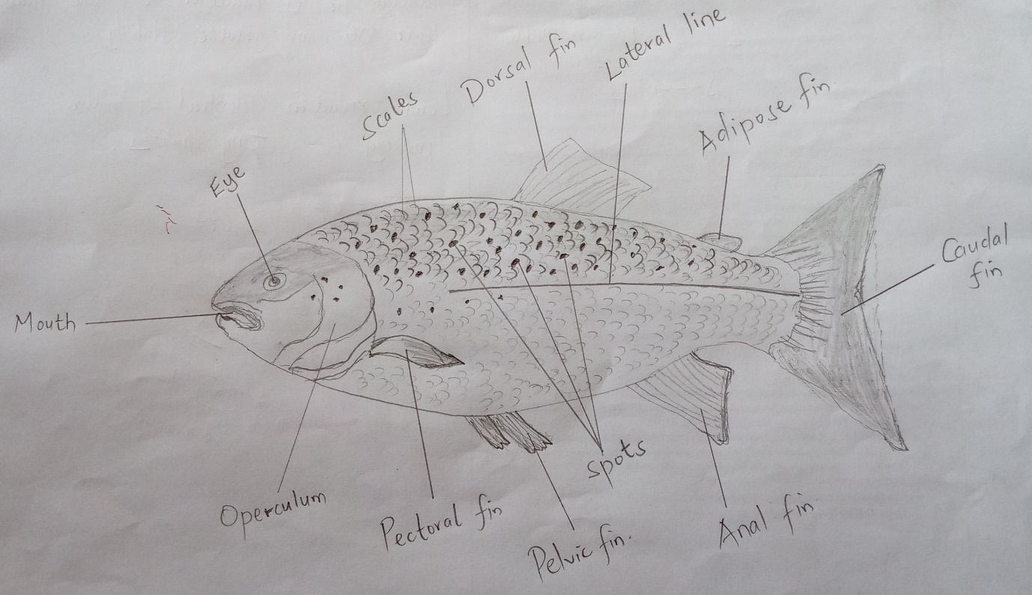Fig 1: Labelled diagram of Salmo salar
Salmo salar has a small pointed head with a body deepening rearward to the deepest point under the dorsal fin. The body has a silver completion with dark crosses and spots across the head, body, and fins. The buccal cavity is relatively large with small and distinguished teeth that are 4-6 in number. Salmo Salar has a narrowly pointed tongue extending to the eyes below (OECD, 2017). Interestingly, Salmo Salar has two dorsal fins, and this is rare among the fishes. The second dorsal fin is small and situated near the tail. The fin lacks fins rays, and it is flesh. The tail fin is somehow forked. The other fins, like pelvic and pectoral fins, are still present. The jawline of salmon extends back to the levels of the eye. The lateral fin is well distinguished and visible from a close range (ICES, 2016). Scales are also observable but reduced in the lower part of the body. The opercula are present on both sides of the body. In addition, eyes are present in the head region. A smolt is a young salmon three or two years of age (OECD, 2017). The smolt salmon is still developing, and it starts turning silvery to assume the color of the adult Atlantic salmon. As for the Parr, this is the stage between full absorption of the yolk sac and smoltification. The parr has brown to bronze-colored bodies. The dark bars and red black spots and are visible.
Ecological Information
Range and distribution: Salmo salar are naturally occurring in the northern hemisphere. They are genetically distributed in a west-Atlantic race and European lineage. The species are separated into other minor regional groupings (Mench & Mason, 1997). The regional distinction is evident for North American species in the population inhabiting the Gulf of Maine, Newfoundland, Ungava, and Inner Bay. For the European species, Atlantic salmon of the Baltic region is different from the general European populations. There is another division between the East-Atlantic when compared to the North-Atlantic population of the Barents Sea area.
Habitat: All the salmons are known for undergoing migrations necessary psychological changes in a transition in habitat from freshwater rivers to coastal seas, and at times get back to the freshwater rivers. The adult Atlantic salmon live in the coastal areas and eat pelagic invertebrates and other small fishes (OECD, 2017). However, most of the adult Atlantic salmon live in seas with little time in freshwater. For the parr, the primary habitat is in the rivers until they grow and start migrating to the sea.
Abundance: During the pre-colonization, the population of adult Atlantic salmon ranged between 10-12 million. Surprisingly, the number of adult Atlantic salmon in the world currently is nearly a quarter million.

Life-history Information
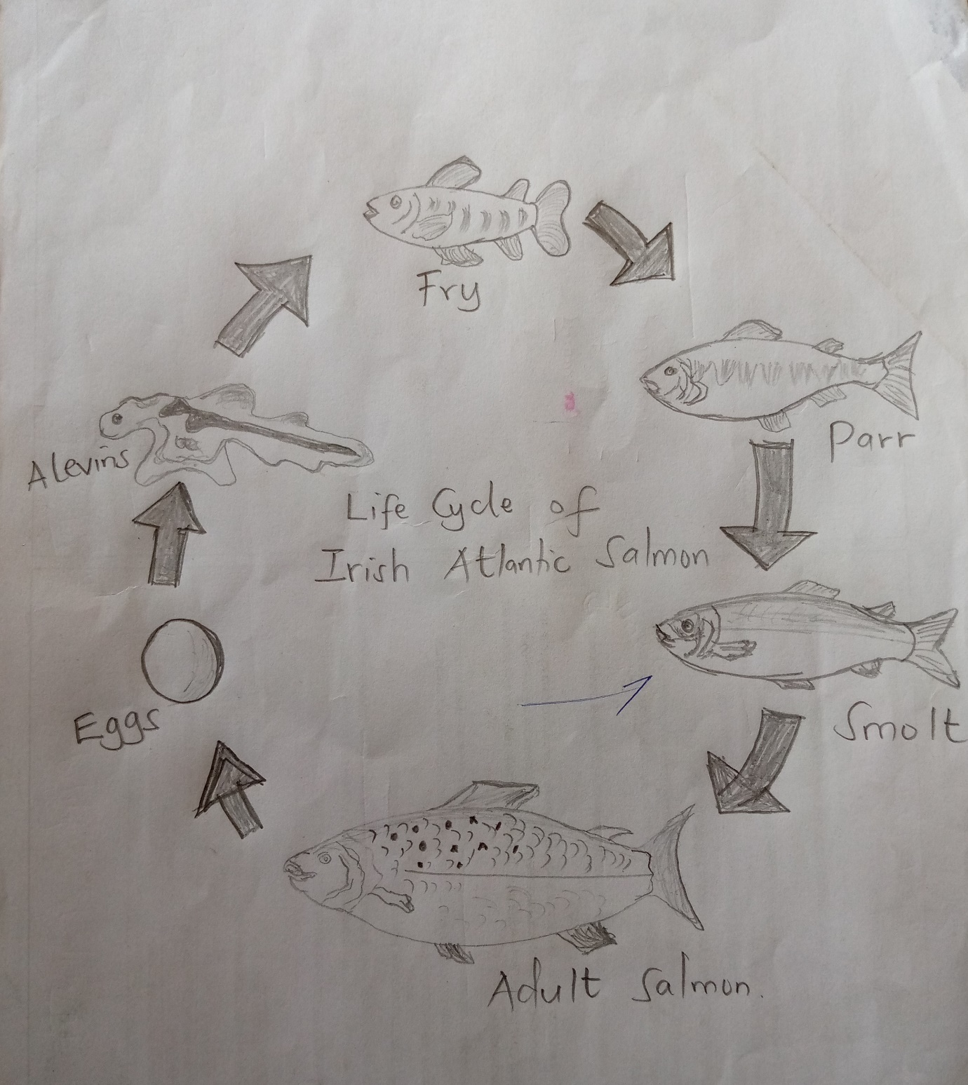
Fig 2: Diagram of the life cycle of Atlantic salmon.
Life-cycle of Salmo salar: This species starts as a small pea-sized egg hidden under loose gravel in calm, clean rivers. The egg develops dependent on water temperature. The egg then develops into alevins which appear as a yolk sac attached to their bodies in spring. Alevins develop to fry. The fry has already started showing almost all traits of an adult life cycle of Salmo salar, with eight fins being visible (Flowers et al., 2017). The fins maintain their position and enable them to move in the water during the summertime. The fry then develops into parr and over the autumn stripe, and spots that help camouflage develop fully (Mench & Mason, 1997). For parr, the fish then becomes smolt ages 1-3 years. Later the smolts become adult salmons, and this is the last stage of their lifecycle. The adults give rise to eggs, and the life cycle begins again.
Life-history in freshwater: The stages found in freshwater are Eggs, Alevins, and fry. The Alevins can swim-up stream in the freshwater, but their swimming is not free like the fry, which has well-developed fins (Flowers et al., 2017). The fry is extremely sensitive to changes in the water quality, climate, and general habitat. In this case, they can note changes in the fresh water and marine ecosystem status.
Life history in the seawater: The parr stage has marked the transition from freshwater ecosystem to seawater habitat. Once the parr has grown to about 10 -25 cm, the body undergoes physiological pre-adaptations to life in the sea by the process of smelting (Mench & Mason, 1997). The primary adaptation is internal changes in the salt-regulating mechanisms. The smolt stage lives entirely in the sea and oceans and migrates along rich feeding grounds in the habitat (Gill, 2003). Adult Salmo salar fully lives in the aquatic environment. They have pheromones that detect changes in the water levels.
Food: The eggs rely on energy stored in the York. Alevins also have energy from the York. Fry feed on microscopic invertebrates. Parr feeds on aquatic insects. As for the smolt, their primary food is small fish like capelin herring and sand eel. Adult salmon feed on the small fish as well, small amphibians, and some crustaceans.
Predators: The parr is commonly predated by fish like brown trout, pike. Smolt's main predators include avian predators (Gill, 2003). The adult salmon are edible by humans, and the activities of fishers significantly affect their population.
Relevance to Humans
Atlantic salmon is of great significance to humans. It is among the highly prized food fish. The increased demands of Salmo salar have led to the development of an active aquaculture industry that has to do with cage rearing, hatcheries, and sea ranching. The most interesting fact is that Salmo salar is rich in fish oil, contains a rich source of health-promoting long-chain omega-3-fatty acids, eicosapentaenoic, and docosahexaenoic acids. The fish has low saturated fat and is a source of protein. Salmon species are the best source of vitamin B12. Vitamin D and potassium nutrients are present in the Salmo salar. In addition, Atlantic salmon is significant for social and ceremonial purposes by many indigenous communities within Canada. The fish earn fishers' income, and the countries get quality revenues from importation. Generally, Atlantic salmon has relevance to humans.

References
Flowers, K. I., Henderson, A. C., Lupton, J. L., & Chapman, D. D. (2017). Site affinity of whites potted eagle rays Aetobatus narinari assessed using photographic identification. Journal of Fish Biology, 91, 1337– 1349
Gill, A. B. (2003). The dynamics of prey choice in fish: The importance for prey size and satiation. Journal of Fish Biology, 63, 105– 116
ICES (2016). Report of the Baltic salmon and trout assessment working group (WGBAST). ICES CM 2016/ACOM:09. Retrieved from: http://ices.dk/sites/pub/Publication%20Reports/Expert%20Group%20Report/acom/2016/WGBAST/w gbast_2016.pdf
Mench, J. A., & Mason, G. J. (1997). Behaviour. In M. C. Appleby & B. O. Hughes (Eds.), Animal Welfare (pp. 127– 142). New York, NY: CAB International
OECD (2017). Consensus Document on the Biology of Atlantic Salmon (Salmo salar). Retrieved from file:///C:/Users/hp/Downloads/OECD%20(2).pdf

